**Restaurant Website**

END TERM REPORT

*By*

**NAME OF THE CANDIDATE (S)-**

Aakarshit Chaurasia Pratham Jain Manisha

(12001847) (12006336) (12010272)

(Roll.no- A33 ) (Roll no.- RK20KAB90) ( Roll no.-A44)

**SECTION-K20KK**



**Department of Intelligent Systems**

**School of Computer Science Engineering**

**Lovely Professional University, Jalandhar**

**April-2021**

**Student Declaration**

This is to declare that this report has been written by us. No part of the report is copied from other sources. All information included from other sources have been duly acknowledged. We aver that if any part of the report is found to be copied, we shall take full responsibility for it.

Aakarshit Chaurasia

Roll no: RK20KKA33

Pratham Jain

Roll no: RK20KAB90

Manisha

Roll no: RK20KKA44

Place-Lovely Professional University

Date-30th April,2021

**Table of Contents**

**Title: Restaurant (M.A.P Food Point)**

…*Abstract*

1. **Introduction**
2. **Background and Objectives of project assigned**

**2.1** *Background and relative work*

**2.2** *Motivation*

**2.3** *Outcomes*

**2.4** *Goals*

**2.5** *Objectives*

1. **Description**
2. **Work devision**
3. **Implementation**
4. **Technologies and Framework**
5. **SWOT Analysis**

**BONAFIDE CERTIFICATE**

*Certified that this project report “****Restaurant website****” the bonafide work of “****Aakarshit Chaurasia****,* ***Pratham Jain*** *and* ***Manisha****” who carried out the project work under my supervision.*

Signature of the Supervisor

Dr. Dhanpratap Singh

UID: 25706

(Department of Computer

Science and Engineering)

**ABSTRACT**

Restaurant website is developed to automate day to day activity of a restaurant. Restaurant is a kind of business that serves people all over world with ready made food. This website is developed to provide service facility to restaurant and also to the customer.

This project is a website designed primarily for a Restaurant which not only provides a proper place to sit and eat meals that are cooked and served on the premises, but also gives an option of home delivery as well . This website will allow restaurant to increase scope of business by reducing the labour cost involved. The website also allows to quickly and easily manage an online menu which customers can browse and use to place orders with just few clicks. Restaurant employees then use these orders to provide them with the best.

**REPORT**

**1.**  **Introduction**

It is known globally that, in today’s market, it is extremely difficult to start a new small-scale business and through the competition from the well-established and settled owners. In fast paced time of today, when everyone is squeezed for time, the majority of people are finicky when it comes to placing a food order. The customers of today are not only attracted because placing an order online is very convenient but also because they have visibility into the items offered, price and extremely simplified navigation for the order.

Now isn’t it a wonderful addition to this, if a person can check how a restaurant looks and how they serves to their customers , before even visited to a restaurant.

This Restaurant Website that I am proposing here, greatly simplifies the ordering process for both the customer and the restaurant. System presents an interactive and up-to-date menu with all available options in an easy to use manner. Customer can choose one or more items to place an order and he/she just need to fill a form and yeah!! That’s it.

**2. Background and Objectives of project assigned**

**2.1 Background and related work**

This Case study looks at the problem of setting up a restaurant. In existing system there are few problems:

• For placing any orders customers have to visit hotels or restaurants to know about food items and then place order and pay. In this method time and manual work is required.

• While placing an order over the phone, customer lacks the physical copy of the menu item, lack of visual confirmation that the order was placed correctly.

• Every restaurant needs certain employees to take the order over phone or in-person, to offer a rich dining experience and process the payment. In today’s market, labor rates are increasing day by day making it difficult to find employees when needed.

Hence, to solve this issue, what we propose is an “Online Restaurant Website”.

2.2 **Motivation**

Nowadays, everyone is busy in their day to day life. Everybody has a tight schedule which sometimes lead them to skip their meals also. By taking this problem into consideration , we were thinking that what we can do for this problem.

The motivation for this comes from our respected sir Dr. Dhanpratap Singh , when he taught us about how to create a website and also our urge to learn HTML. We decided to make/ design a website which will be very useful to the customers as well as Restaurants also.

**2.3 Outcomes**

. 1. The system will help to reduce labour cost involved.

2. The system will be less probable to make mistake, since it’s a machine.

3. This will avoid long queues at the counter due to the speed of execution and number of optimum screens to accommodate the maximum throughput.

**2.4 Goals**

The main goal of our website is to greatly simplifies the ordering process for both the customer and the restaurant and also to greatly lightens the load on the restaurant’s end, as the entire process of taking orders is automated.

**2.5 Objectives**

1. To create a website which will help to reduce the number of employees at the back of the counter.

2. To create a user friendly system which saves the time of the customers .

3. Responding website, so that it will be easy to navigate.

**3 DESCRIPTION**

MAP Food Point is a Restaurant website design to help customers as well as Restaurants to make their work easy and less time consuming.

**Modules**

The elements present in the websites are:

* **Home page**

On Home page , customer can see the overview of the whole restaurant website which includes the navigation bar to move to another pages of this website. It also includes some pictures and some of the dishes of this Restaurant.

* **About us**

On this page, customer can check all the information about the Restaurant ., including the owners of the restaurant

* **Menu**

On clicking on the menu button, it show two option that whether someone wants to view the Menu or want to Download it.

From there customer can check the menu of the restaurant without even visiting there.

* **Reserve table**

If Customers wants to save some extra time, then this button will b the most useful for them. They can reserve a table before visiting the Restaurant.

* **Gallery**

On the gallery page customer can view the Amazing locations of the Restaurant.

It also includes the images of the Kitchen and some Aesthetic picture points of the Restaurant.

* **Healthy Tips**

This page provides some of the healthy tips to the customer, which can help them to create a healthy environment around them.

* **Contact us**

If a customer wants to ask about anything then he/she should visit this page only.

* **Home Delivery**

This is the most important thing for the customers having a tight schedule, so that they can enjoy the delicious food without even wasting their time in travelling.

Zomato, Swiggy, etc are available for the delivery.

* **Offers**

This Restaurant also provides you the amazing offers which helps to in exploring more.

* **Challenges**

Several challenges and Fun activities are also available for the customers, which attracts them to the Restaurant.

**4 Work Division:**

There are 3 members in our group, work was divided to each one of them as per their knowledge and capability.

The contribution of each student is discussed below ,in brief:

1.***Aakarshit Chaurasia:***

He is the group leader of the project. He has done the complete coding of website. Starting from the main Home page of the website to link page into that is done by him, using his knowledge of HTML and CSS. He edited the whole website.

***2.Pratham Jain:***

He did the coding of small web pages by using his knowledge of HTML and provides with the best ideas about offers and challenges. He also suggested that how the restaurant should take online orders as well.

***3.Manisha:***

She prepared the Report by observing the entire period of creating this website, right from the beginning of this Project. She helped in making the website looking attractive by providing designing to this website. She also suggested few ideas which is implemented in this website.

In addition to this, all 3 of us did regular Google meet for helping each other throughout the whole process.

**5. Implementation**

**Front page :**The main home page looks like this which has navigation bar which includes about us, menu, gallery,etc.

Specialities are also available on the home page.

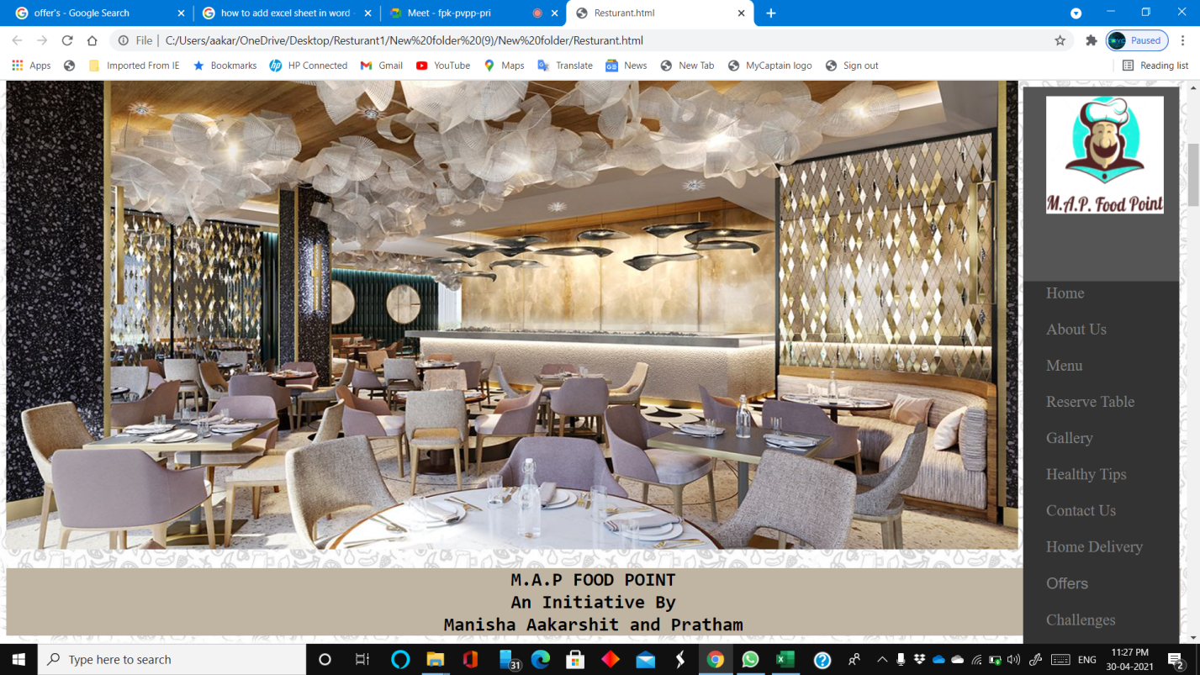

Our specialities:

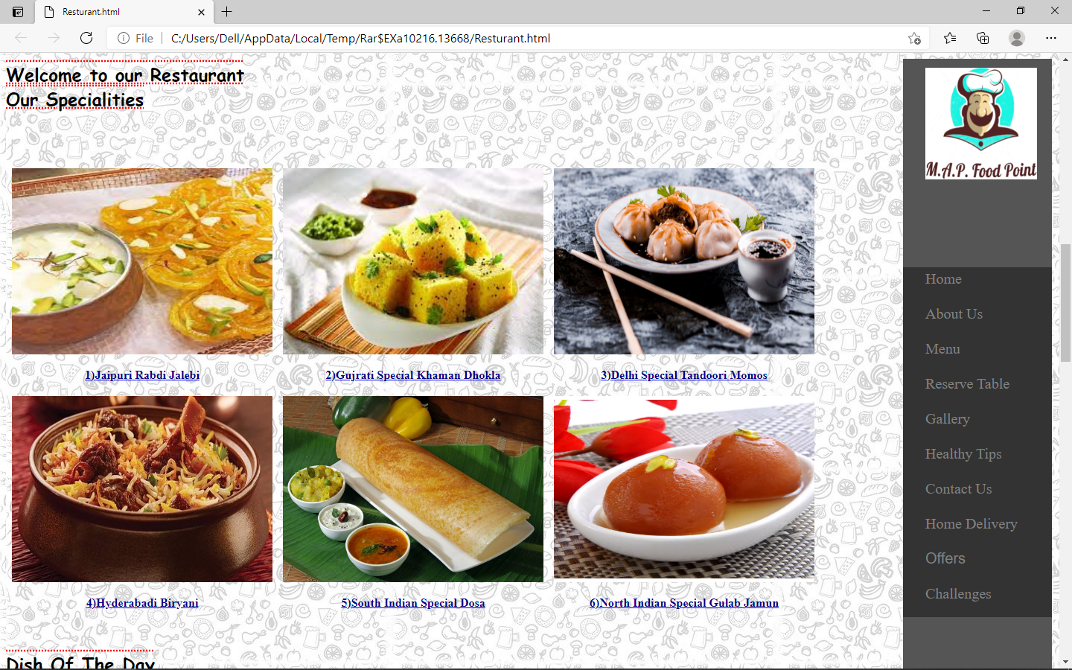

Dish of the day:

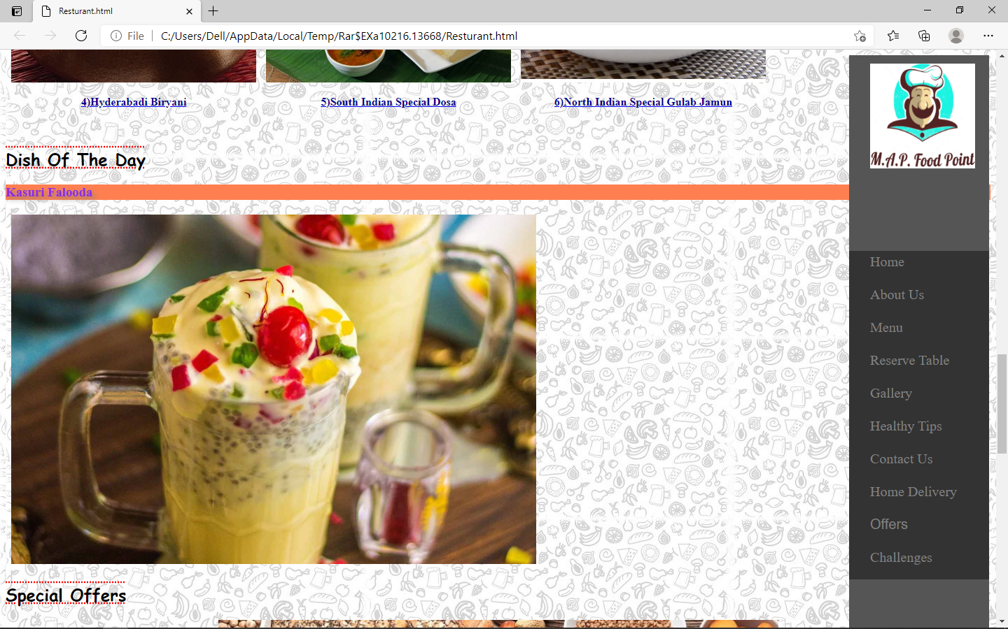

On clicking on ABOUT US button..the page shown below is open which contains some info about us.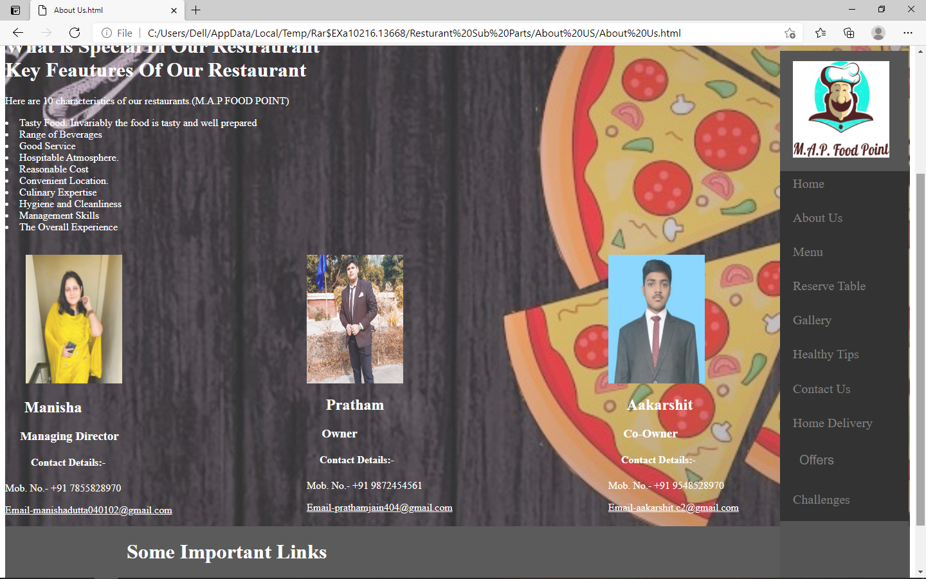

On clicking on Menu..the page shown below opens from which the customer can view or download the menu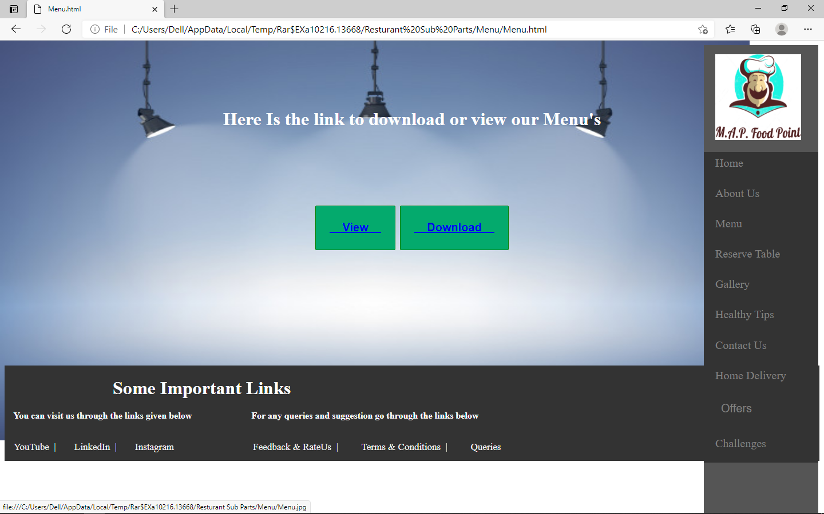

Menu:

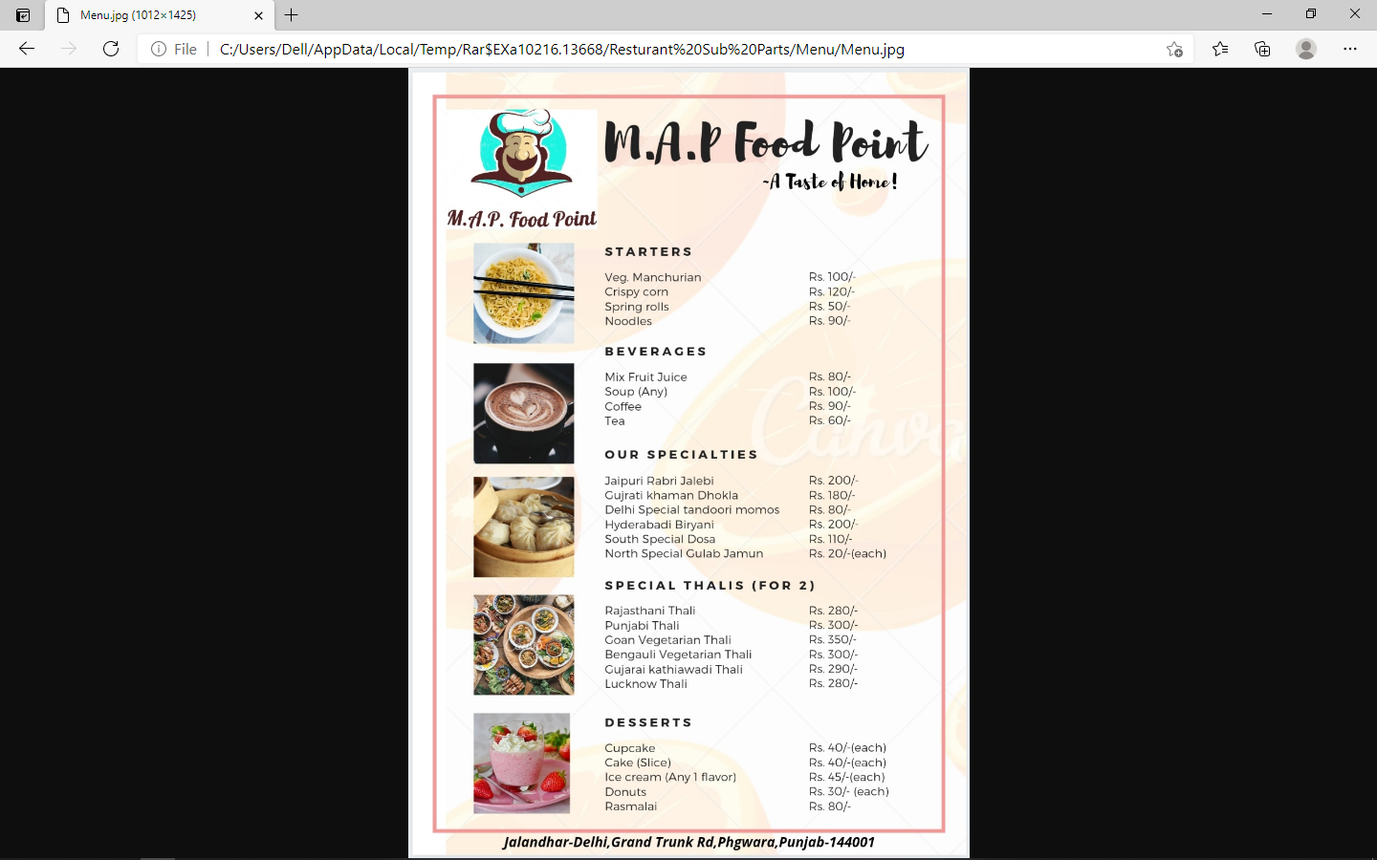

Reserve Table: from this customers can book a table before visiting the Restaurant.

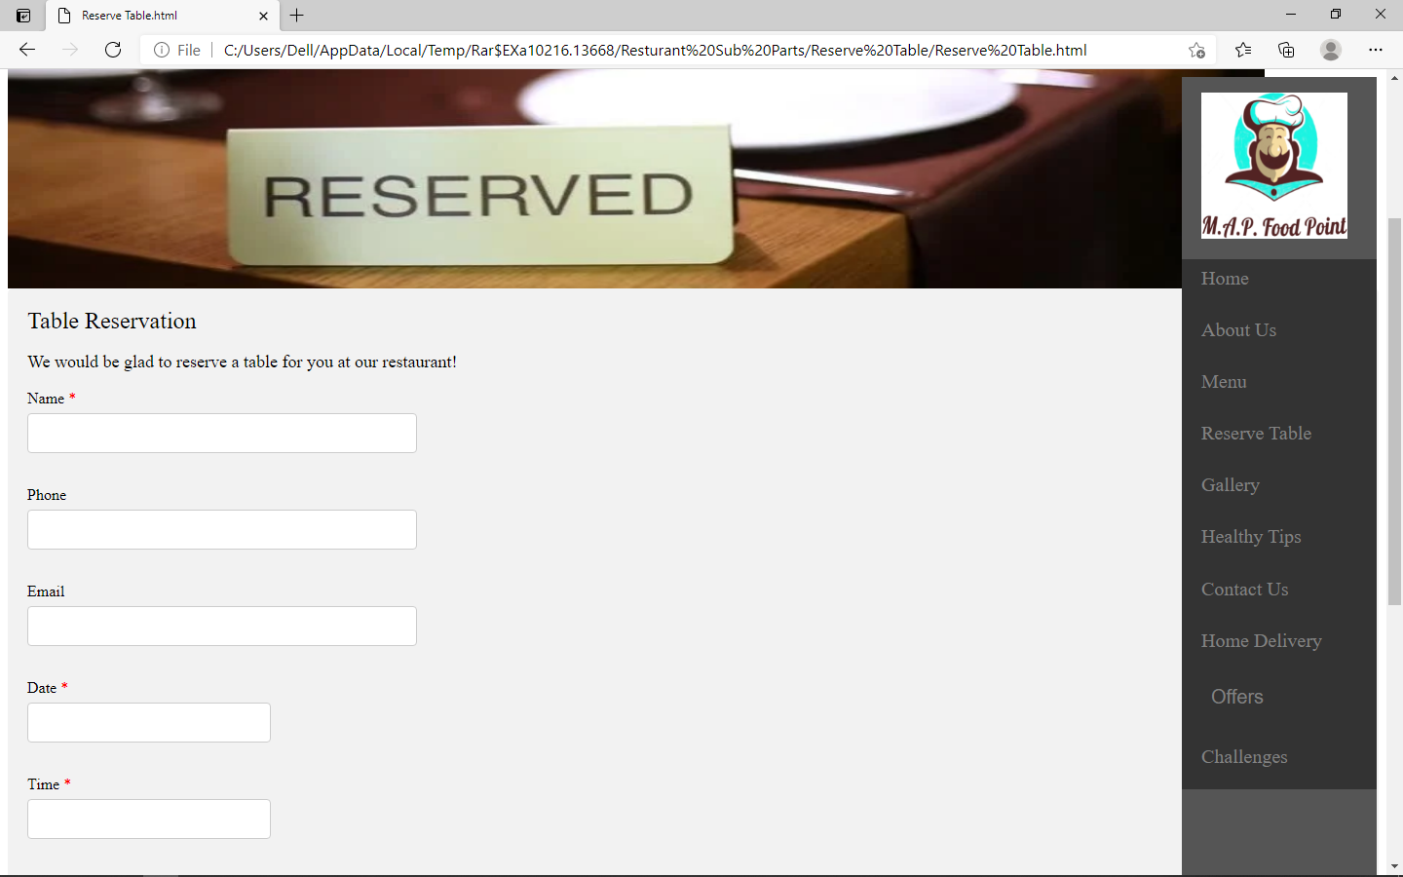

Next is the Gallery button which shows the images of the Restaurant . Sample is given below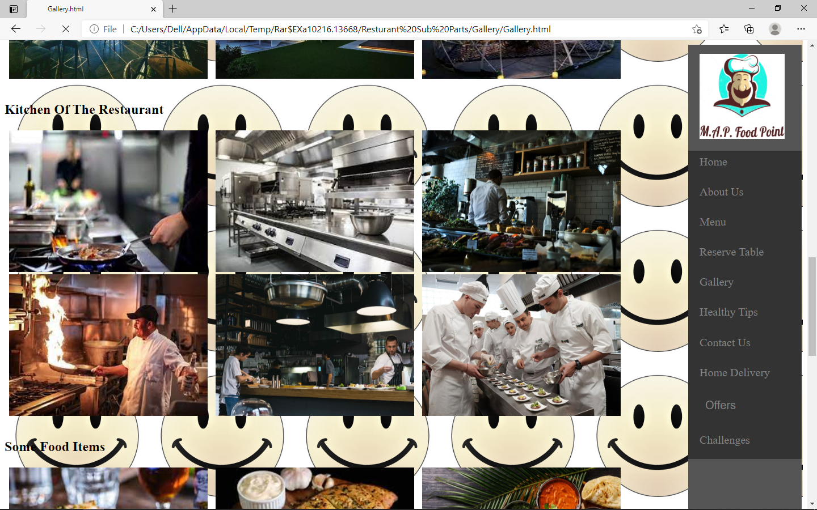

Contact us button:

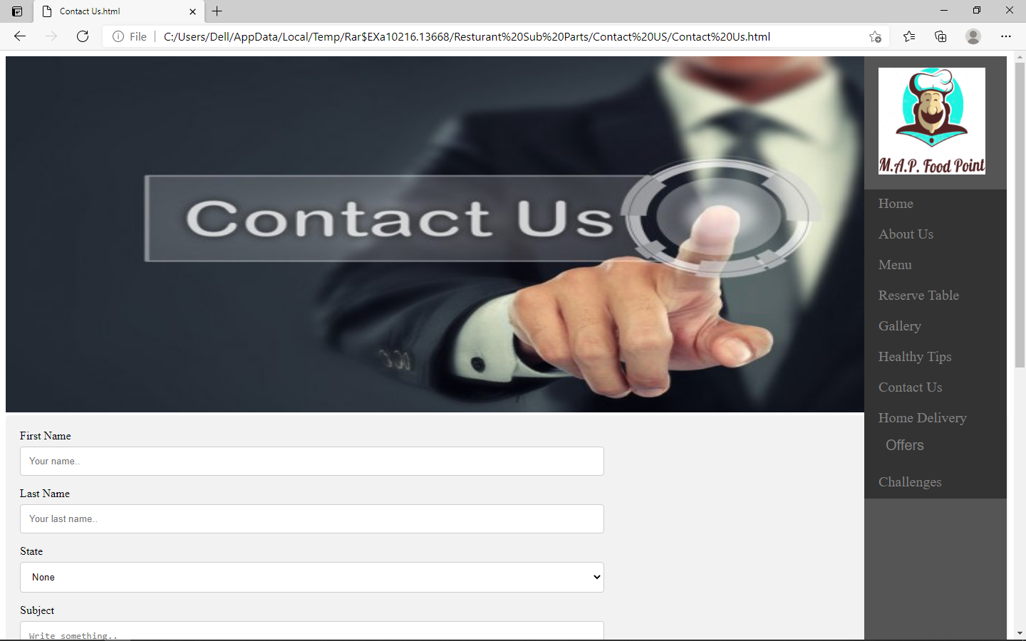

For home delivery ,customer can visit on the below..

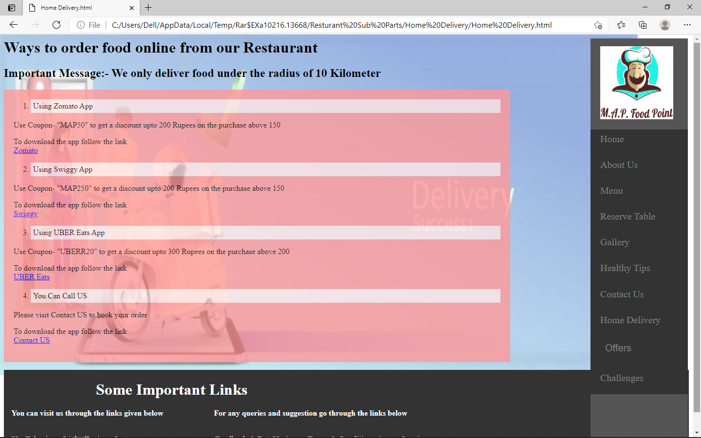

Some offers that are provided to the Customers: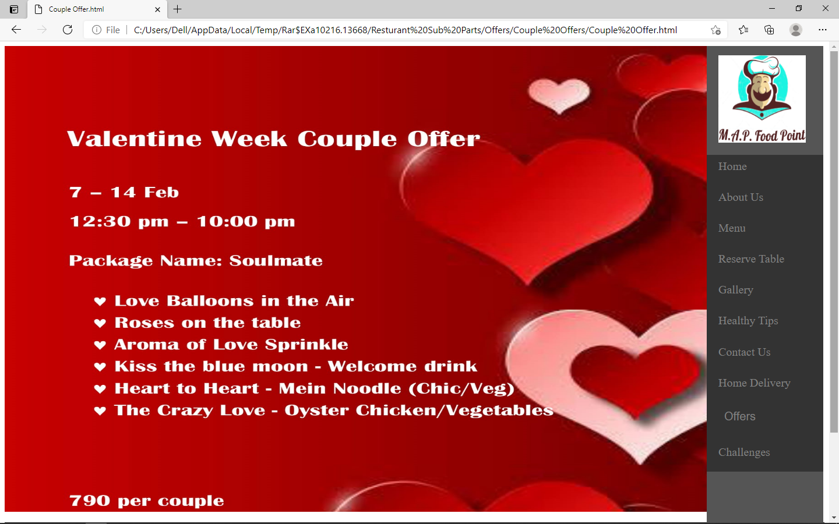

Some amazing Food Challenges:

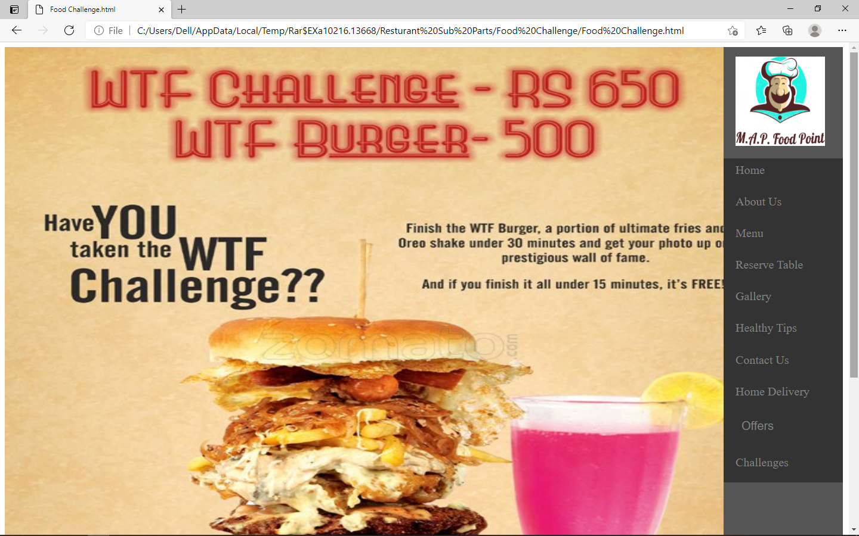

**6. Technologies and Framework**

* HTML, CSS and JS ( a small part) is used in this website.
* For writing Codes, Notepad++ and VS code is used.
* Google images are referred for the gallery.

**7. SWOT analysis:**

***Strengths:***

* Relevant and unique code
* User friendly design
* Good hosting service
* Easy navigation and search

***Weaknesses:***

* Internet is required
* Difficult to access this on smaller screen devices

***Opportunities:***

* New Technologies
* Innovative marketing statergies
* Positive changes in Social Factors

***Threats:***

* Fraudulent activity
* Changing customer needs